Transport and Infrastructure Council

National Standard
for
The Australian Builders Plate
for Recreational Boats

Edition 5

EDITION 1
First Published: 1 March 2005 – Edition 1 (PDF version)
EDITION 2
April 2005 – Edition 2 (CD)
EDITION 3
21 November 2005 – Edition 3 (PDF version on web) incorporating Amendment 1 to Edition 2
EDITION 4
23 May 2011 – Edition 4 (PDF version on web) incorporating Amendment 1 to Edition 3 as well as National Guidance Circular 07-1 and elements from the Implementation Package for the National Standard for the Australian Builders Plate for Recreational Boats.
EDITION 5
5 June 2020 – Edition 5 (PDF version on web) revised edition.
Endorsed by the Transport and Infrastructure Council

© Commonwealth of Australia
This work is copyright. Apart from any use as permitted under the Copyright Act 1968, no part may be reproduced by any process without written permission of the Australian Recreational Boating Safety Committee (ARBSC).
Published by the Australian Recreational Boating Safety Committee.
ISBN 978-0-646-82080-4

Contents

Contents 3
FOREWOrD 4
Part 1 Preliminary 6
1.1 Objective 6
1.2 Scope 6
1.3 Application 6
1.4 Referenced documents 7
1.5 Terms and definitions 9
1.6 Abbreviations 12
Part 2 GENERAL REQUIREMENTS 13
2.1 Scope 13
2.2 Location 13
2.3 Fixing 13
2.4 Marking 14
2.5 Items of information to be displayed 14
2.6 Symbols 15
2.7 Size of text and symbols 16
2.8 Design of the ABP 16
2.9 Provision of additional safety information 16
2.10 Example plates 16
Part 3 Specified Standards and THE determination of information on a plate 17
3.1 Scope 17
3.2 Determination of information 17
3.3 Use of specified standards 18
3.4 Conversion to metric values 19
Part 4 Information to be displayed on the plate 21
4.1 Scope 21
4.2 Information required to be displayed on an ABP 21
Annex A TEMPLATES FOR AUSTRALIAN BUILDERS PLATES 28
A.1 Scope 28
A.2 ABP templates for boats less than 6 metres in length 28
A.3 ABP templates for boats 6 metres or more in length 32

FOREWOrD
Introduction
This Standard was developed by the National Marine Safety Committee (NMSC) in response to public demand for recreational boat safety and with the support of Australian boat builders. It is a standard for an Australian Builders Plate (ABP) that is fixed to certain recreational boats used in Australia. An ABP is a plate that displays basic safety information for the consumer about the boat’s maximum loading, passenger capacity, outboard engine rating and engine weight, operational limits, and in addition for boats less than 6 metres in length, information about the boat’s buoyancy performance.
This Standard specifies the boats to which the Standard applies, the requirements for the uniform display of information to be exhibited on the ABP, and most importantly the design and construction standards to be used in determining that information.
The Australian Recreational Boating Safety Committee (ARBSC) assumed responsibility for national coordination of recreational boating safety and hence the content and publication of this standard in 2010.
Background
The Australian Transport Council (ATC) established the NMSC in 1997 under a Council of Australian Governments (COAG) Intergovernmental Agreement to promote a uniform national approach to marine safety in Australia.
The NMSC subsequently prepared a National Marine Safety Strategy, which was endorsed by the ATC. The Strategy, as published in 1998, identified a number of actions necessary to achieve and sustain a uniform national approach to marine safety, including the following:
- Develop and encourage the adoption and use of a common framework of objectives and standards for recreational boats.
- Encourage competency and responsible use of recreational boats.
This Standard addresses the recreational boat standards component of the national safety system.
The NMSC ceased to operate formally in 2009, and the Australian Transport Council was subsumed into the Transport and Infrastructure Council in 2013.
Since that time responsibility for the maintenance and publication of this standard has moved to the Australian Recreational Boating Safety Committee, under the oversight of the Marine Agencies Forum, reporting to the Transport and Infrastructure Council.
Adoption and implementation of the ABP
The ABP has been adopted through the maritime or consumer legislation of each State and the Northern Territory of Australia. Model legislative clauses and a legislative intent statement were prepared by the NMSC in collaboration with the Parliamentary Council’s Council, to ensure consistency in the adoption of the ABP around Australia. In addition, an implementation package was developed to provide guidance to jurisdictions on implementation and compliance activities.
Where it is a legislative requirement that a recreational boat be fitted with an ABP, the requirements in this standard, including its application, may be modified by that legislation.
Publication history and amendments
This standard was first endorsed by the Australian Transport Council (ATC) on 23 May 2003. Edition 1 of the standard was published in hard copy and online in PDF format in March 2005.
Edition 2 was published on CD in April 2005. In Edition 2 Clauses 8.1c) and d) were amended to allow for a separate Australian Builders Plate for boats less than 6 metres in length without an outboard. Two additional figures were added to illustrate this option.
An amendment to Edition 2 was endorsed by the ATC on 18 November 2005 resulting in the publication of Edition 3 (ISBN 0 642 73637) on 21 November 2005 in PDF format. This edition included changes to the definitions of maximum load and suitcase symbol at Clause 5, and changes to Clauses 7.3, 7.3 a), b), c), 8.1g), 8.1.j), 8.2g) 8.2.i), 9.4 and 9.6. Edition 3 was the first edition to be referenced in state legislation.
Edition 4 was endorsed by the ATC on 20 May 2011 and published on 23 May 2011 (ISBN 978-0-642-73677-2) in PDF format. Edition 4 was developed to capture within the standard clarifications of requirements, such as those in NMSC Guidance Circular 07-1 and in the Implementation Package issued with the standard. Feedback from the Australian Competition and Consumer Commission (ACCC) on the manner in which the standard was drafted was also incorporated.
This Edition (Edition 5) was endorsed by the Transport and Infrastructure Council on 5 June 2020. It includes major changes to the structure and format of the standard to make it easier to navigate and to assist builders in using and complying with the standard. It also includes changes to the presentation of person capacity, switching from optional to mandatory warning statements and the moving of reserve outboard mass from maximum outboard mass to maximum load. The concept of full compliance was added to improve consistency between specified standard values and the values displayed on a builders plate, and this change was accompanied by a change requiring that flotation is fitted in accordance with the requirements of the nominated standard. An exemption has also been introduced for Personal Watercraft compliant with ISO 13590.
This Edition of the Standard is published online at www.anzsbeg.gov.au.
- Preliminary
  - Objective
The objective of this standard is to enhance the safety of persons on a recreational boat. It does this by providing for—
- a declaration by the builder that the boat meets, to the extent specified within this Standard, the requirements of the specified standards applicable to the design and construction of recreational boats;
- ready access to essential safety information on the limitations applicable to the use of the boat to encourage appropriate and responsible use of the boat; and
- information on the buoyancy characteristics of the boat so that persons may make informed decisions regarding its purchase and use.
  - Scope
This Standard establishes requirements for—
- certain recreational boats to have a plate (Part 1);
- the location of the ABP on a recreational boat (Part 2);
- the fixing of the ABP to a recreational boat (Part 2);
- the markings, text and symbols displayed on the ABP (Part 2);
- the design of the ABP (Part 2);
- the technical standards to be used in determining the information to be displayed on the ABP (Part 3); and
- the information to be exhibited on the ABP (Part 4).
  - Application
This Standard shall apply to any recreational boat, with the exception of the following types of recreational boats:
- Aquatic toys.
- Amphibious vehicles.
- Canoes, kayaks and similar boats designed to be paddle-powered such as surf skis.
- Hydrofoils and hovercraft.
- Pedal powered boats.
- Personal Watercraft intended to carry no more than two persons.
- Personal Watercraft compliant with ISO 13590.
- Paddleboards.
- Racing boats.
- Rowing shells used for racing or rowing training.
- Sailboards.
- Sailing boats.
- Stand-up paddleboards.
- Submersibles.
- Surf row boats.
- boats more than 24 m in length.
The exception for rowed or paddled craft specified in clauses 1.3 (c), (e), (h), (i), (j), (k), and (m) is limited to a recreational boat that, as designed and built, is incapable of being fitted with an outboard motor.
NOTES:
- This Standard applies to inflatable boats.
- Enabling legislation may provide further details of the types of boats required in law to be fitted with an ABP in accordance with this standard.
    - Application to inflatable boats
This standard shall apply to inflatable boats except where the inflatable boat—
- has a plate attached to it in accordance with Directive 2013/53/EU– Recreational Craft Directive (as in force from time to time) that certifies that the boat complies with the requirements of that Directive; or
- has a plate attached to it in accordance with the requirements of National Marine Manufacturers Association (US) set out in ABYC S-7 (ANS) – Boat capacity labels (as in force from time to time) that certifies that the boat complies with the requirements of those standards.
    - Application to personal watercraft carrying more than two persons
This standard shall apply to a personal watercraft intended to carry more than two persons, except where the craft has the following information permanently marked in a clearly visible place—
- the total mass of persons and equipment that the boat may carry (expressed in kilograms); and
- the maximum number of persons the craft may carry.
NOTE: Personal watercraft compliant with ISO 13590 are exempt from the requirements of this Standard.
  - Referenced documents
The following documents are referred to in this Standard. Any document referenced in this Standard should be considered to be a reference to the latest revision of the document, including amendments.
NOTE: The referenced document applicable to a particular boat shall be the latest revision of the document, including amendments, applicable at the commencement of the boat’s construction.
AMERICAN BOAT AND YACHT COUNCIL
ABYC Standards and Technical Information Reports for Small Craft
ABYC H-5 (ANS) – Boat load capacity
ABYC H-8 (ANS) – Buoyancy in the event of flooding/swamping
ABYC H-26 (ANS) – Powering of boats
ABYC H-28 (ANS) – Inflatable boats
ABYC H-35 (ANS) – Powering and load capacity of pontoon boats
ABYC S-7 (ANS) – Boat capacity labels
ABYC S-30 (ANS) – Outboard engine and related equipment weights
EUROPEAN COMMISSION
DIRECTIVE 2013/53/EU on recreational craft and personal watercraft and repealing Directive 94/25/EC
INTERNATIONAL ORGANIZATION FOR STANDARDIZATION
ISO 6185—Inflatable boats
Part 1: Boats with a maximum motor power rating of 4.5 kW
Part 2: Boats with a maximum motor power rating of 4.5 kW to 15 kW inclusive
Part 3: Boats with a hull length less than 8 m with a motor rating of 15 kw and greater
Part 4: Boats with a hull length of between 8 m and 24 m with a motor power rating of 15 kW and greater
ISO 8665—Small craft – Marine propulsion reciprocating internal combustion engines – Power measurement and declarations
ISO 8666—Small craft – Principal data
ISO 10087—Small craft – Craft identification – Coding system
ISO 11192—Small craft – Graphical symbols
ISO 11592—Small craft – Determination of maximum propulsion power rating using manoeuvring speed
ISO 12217—Small craft – Stability and buoyancy assessment and categorization
Part 1: Non-sailing boats of hull length greater than or equal to 6 m
Part 2: Sailing boats of hull length greater than or equal to 6 m
Part 3: Boats of hull length less than 6 m
ISO 13590—Small craft – Personal watercraft – Construction and system installation requirements
ISO 14946—Small craft – Maximum load capacity
NATIONAL MARINE MANUFACTURERS ASSOCIATION (US)
Program Standard Basis
SOCIETY OF AUTOMOTIVE ENGINEERS
SAE J 1973—Personal watercraft – Flotation
STANDARDS AUSTRALIA
AS 1799.1—Small craft – General requirements for power boats
  - Terms and definitions
For the purposes of applying this Standard, the following terms and definitions shall apply:
aquatic toy—
an object designed for play in or on the water. It includes, but is not limited to—
- an object designed solely to be towed behind a recreational boat; and
- an inflatable boat to which the ISO 6185 series does not apply.
Australian Builders Plate—
a plate that displays information, in accordance with the requirements of this Standard, about the boat to which it is fixed.
Australian Recreational Boating Safety Committee—
an intergovernmental committee comprising representatives of the statutory marine authority of the Commonwealth of Australia, the Northern Territory, and each State of the Commonwealth.
Australian Transport Council—
A Council formed by the Council of Australian Governments (COAG), comprising the Commonwealth, State, Territory and New Zealand Ministers with responsibility for transport. This Council was subsumed into the Transport and Infrastructure Council in December 2013.
auxiliary outboard—
an outboard engine, of a lower power rating than the primary engine or engines, intended for use as an alternative means of mechanical propulsion to the primary means of propulsion. This includes reserve outboard motors and electric trolling motors.
basic flotation—
a flotation system that will keep a boat carrying its maximum load from sinking when swamped, assuming the occupants of the boat have left it and are in the water clinging to it. With basic flotation the swamped boat may float at any attitude.
NOTE: This definition of “basic flotation” is for the purposes of applying this standard and may differ from the definition in a specified standard. The definition of “basic flotation” to be used for the purpose of applying any specified standard, is the definition of “basic flotation”, or its equivalent term, within the specified standard being used.
EXAMPLE
If AS 1799 is used to determine a boat’s buoyancy performance and basic flotation is to be fitted, the definition and performance requirement for basic flotation in that standard is to be used.
boat—
a recreational boat (as defined below).
build date—
the month and year of production of a boat.
builder—
the person who completed the construction of the boat to a point where it is suitable for use in its intended fashion.
competent person—
a person who has acquired through training, qualification, experience, or a combination of these, the knowledge and skills enabling that person to competently determine and approve the information on a builders plate.
determine—
in relation to the determination of information on a plate means to arrive at the value(s) to be displayed on a plate by following the method and carrying out all calculations, tests and steps set out in the specified standard for that item of information.
flybridge—
the highest accessible deck of a vessel above the main cabin, usually equipped with navigation controls. The deck may be open, or covered.
NOTE: A flybridge is a common feature on larger yachts or cabin cruisers and often provides a secondary point for navigating the vessel.
Hull Identification Number—
a number, in a form and of a size, specified in ISO 10087, permanently affixed to, and located in the positions on, the hull of a boat as specified by that Standard.
NOTE: The term Craft Identification Number (CIN), used in certain specified national and international standards, is synonymous with the term Hull Identification Number.
length—
a term having the same meaning as “length of the hull” in ISO 8666.
NOTE: This definition of length is for the purposes of applying this standard only. The definition of “length” to be used for the purpose of applying any specified standard to determine the information required on the plate, is the definition of “length”, or its equivalent term, within the particular specified standard.
level flotation—
a flotation system that will keep a boat carrying its maximum load from sinking when swamped, assuming the occupants remain within the boat and supported by the flotation system. The flotation system must be such that it will keep the swamped boat floating level, and prevent it from capsizing in calm water. Level flotation does not provide a self-righting capacity.
NOTE: This definition of “level flotation” is for the purposes of applying this standard and may differ from the definition in a specified standard. The definition of “level flotation” to be used for the purpose of applying any specified standard, is the definition of “level flotation”, or its equivalent term, within the specified standard being used.
EXAMPLE
If AS 1799 is used to determine a boat’s buoyancy performance and the boat is to be fitted with level flotation, the performance requirement for level flotation in that standard is to be used.
may—
indicates, in the context of its use, an option with or without conditions.
note—
indicates, in the context of its use, that the information is explanatory in nature, providing advice to the reader on the meaning of a requirement, and drawing attention to other relevant requirements within the standard.
paddleboard—
a board designed to be propelled through the water by a rider kneeling, sitting or lying on the board.
Personal Watercraft (PWC)—
a watercraft intended for sports and leisure purposes of less than 4 m in hull length which uses a propulsion engine having a water jet pump as its primary source of propulsion and designed to be operated by a person or persons sitting, standing, or kneeling on, rather than within, the confines of a hull.
plate—
the Australian builders plate for recreational boats.
racing boat—
a vessel that is built solely for racing and is not otherwise intended by the builder for use as a recreational boat.
recreational boat—
a vessel used solely for pleasure and recreation that is not used for a commercial purpose or in connection with a business.
sailing boat—
a vessel that has sail as the primary means of propulsion, with or without an auxiliary means of mechanical propulsion.
shall—
indicates, in the context of its use, that a requirement expressed in a clause is mandatory for the purpose of complying with this Standard.
should—
indicates, in the context of its use, advice or information. The term is used, however, to highlight safety issues that should be considered and addressed.
specified standard—
a standard published by a recognised national or international standard setting body, that is listed in this Standard as a referenced document, and is specified in this Standard as a standard to be used in determining the information on the ABP.
NOTE: A list of specified standards can be found in Table 3.
stand-up paddleboard—
a board designed to be propelled through the water by a rider standing upright using a long-handled paddle.
Transport and Infrastructure Council—
A Council formed in December 2013 by the Council of Australian Governments (COAG), comprising the Commonwealth, State, Territory and New Zealand Ministers with responsibility for transport and infrastructure issues, as well as the Australian Local Government Association.

  - Abbreviations
ABP—
Australian Builders Plate
ABYC—
American Boat and Yacht Council
HIN—
Hull Identification Number
ISO—
International Standards Organization
PWC—
Personal watercraft
NMMA—
National Marine Manufacturers Association (US)
SAE—
Society of Automotive Engineers
- GENERAL REQUIREMENTS
  - Scope
This Part of the standard specifies the requirements pertaining to—
- the location of the ABP on a recreational boat;
- the fixing of the ABP to a recreational boat;
- the markings, text and symbols displayed on the ABP;
- the items of information to be displayed on the ABP; and
- the design of the ABP.
This Part does not specify the content of the information to be displayed on the plate, or the specified standards this content needs to meet. These requirements can be found in Part 3 and Part 4 of this standard.
  - Location
The ABP shall be affixed to the boat in a prominent position, and shall be readily visible to the operator of the boat when getting the boat underway.
To meet this requirement the plate shall be positioned in a prominent and visible location either—
- in the cockpit; or
- near the primary steering position.
Where the design of the boat precludes placement in either of these locations, then the plate shall be placed in another prominent location on board the boat where it is readily visible to the operator of the boat when getting the boat underway.
More than one ABP may be affixed to a boat to help satisfy this requirement. Where more than one ABP is affixed then the information contained on each of the plates shall be identical, and shall fully comply with this standard.
    - Boats with a flybridge
Where a boat is fitted with a flybridge an additional plate shall be affixed to the flybridge in a prominent position adjacent to the flybridge steering position.
NOTE: In addition, a warning statement specifying the person capacity on the flybridge is required to be displayed on all boats with a flybridge. This requirement is set out in Item 11 of Table 4.
  - Fixing
The ABP shall be permanently fixed to the vessel in a manner that is resistant to removal without leaving some obvious sign.
  - Marking
Text, symbols and other markings on the ABP shall be carved, stamped, burned, embossed, moulded, etched, printed, affixed by permanently setting adhesive, or be applied by such other suitable means so that they shall be—
- capable of withstanding the combined effects of water, oil, salt spray, direct sunlight, heat, cold and wear expected in the normal operation of the boat, without loss of legibility; and
- resistant to alteration of information without leaving some obvious sign.
Text, symbols and other markings on the ABP shall be of a colour that contrasts to the background.
Colours applied to the ABP shall be resistant to fading.
  - Items of information to be displayed
The plate shall contain each of the items of information listed in Table of this standard, in accordance with the boats length and engine type.
The information and values provided for each item shall—
- be determined using a specified standard in accordance with Part 3 of this standard; and
- meet the requirements set out in Part 4 of this standard.
Table 1—Items of information to be included on an ABP
by boat length and engine type
# |  | Item | Boats less than 6 m |  | Boats 6 m or more
 |  |  | With outboard | Without outboard | With outboard | Without outboard
1 |  | Title
2 |  | Name of builder
3 |  | Outboard engine power rating
4 |  | Outboard engine mass
5 |  | Person capacity
6 |  | Maximum load
7 |  | Buoyancy statement |  |  | / | /
8 |  | Warning statement (1)–alteration
9 |  | Warning statement (2)–capacity
10 |  | Warning statement (3)–flybridge
11 |  | HIN (or build date)
12 |  | Specified standard used
13 |  | Additional safety information | At the discretion of the builder
Key
/ | = mandatory item of information  = mandatory additional item of information for boats with a flybridge  = optional item of information
  - Symbols
Information on the ABP may be displayed using symbols to identify the item the accompanying information or values relate to.
Where symbols are used, the symbols shall—
- be as illustrated in in Table 1 of this standard; and
- be used for denoting the item of information specified in Table 1.
Where symbols are not used, the name of the item shall be displayed in text.
Table 1—Symbols that may be used on an ABP
Symbol |  | Item of information the  symbol denotes
person symbol |  | person capacity
suitcase symbol |  | all elements of maximum load not represented by person and outboard mass  NOTE: this is not used as a stand-alone symbol but in conjunction with the person symbol, and where appropriate the engine symbol, to denote maximum load
outboard engine symbol |  | outboard engine power rating  &  outboard engine mass
person+ suitcase symbols |  | maximum load  NOTE: for boats without an outboard engine
person+ suitcase+  outboard engine symbols |  | maximum load  NOTE: for boats with an outboard engine
warning symbol |  | warning statement/s
  - Size of text and symbols
The text and/or symbols used to display information on an ABP shall be clearly legible and shall not be less than the minimum requirements for height specified in Table 2.
Table 2—Size of text and symbols to be used on the ABP
Item | Measurement  minimum  height in mm
All text used to display the following information:  - Outboard engine power and mass  - Person capacity and load capacity  - Buoyancy statement | 5 mm
Any symbols specified in Table 1. | 8 mm
All other information on the ABP. | 3 mm
  - Design of the ABP
This standard does not prescribe the shape, size, material, or layout of the plate itself. These aspects of the design of the plate are at the discretion of the person responsible for determining the information and fitting the plate, provided the plate complies with all other requirements of this standard, including those relating to size and legibility of the text and symbols on the plate.
  - Provision of additional safety information
The person responsible for determining the information and fitting the plate, may also provide additional safety or product information on the ABP. This shall be displayed in the space provided on the ABP for such a purpose. The inclusion of this information shall not impair the legibility of the information that is required by this Standard to be displayed.
  - Example plates
Illustrations of sample plates are provided in Annex A as guidance to assist in plate design.
- Specified Standards and THE determination of information on a plate
  - Scope
This Part of the standard specifies the requirements pertaining to—
- the responsibilities of builders and other parties in determining the information on the ABP;
- the specified standards to be used in determining the information to be displayed on the ABP; and
- the consistent application of specified standards in determining the information on the ABP.
  - Determination of information
    - Competent person to determine information
The information displayed on the ABP shall be determined by a competent person.
NOTE: A competent person is defined in Clause 1.5.
    - Responsibility for determining the information to be displayed
The boat’s builder shall be responsible for determining the information to be displayed on an ABP and for ensuring the ABP is affixed to the boat, in full compliance with this standard.
Where a boat, which does not carry a plate that complies with this standard, is imported into the Commonwealth of Australia for the purposes of sale to a consumer, then the importer of the boat shall assume the responsibilities of the boat’s builder and shall be responsible for determining the information on the plate and for affixing the plate to the boat in full compliance with this standard.
NOTE: The importer should determine the information on the plate in coordination with the boat’s builder.
Where a boat, that carries an ABP provided by a builder or importer, is modified in a manner which invalidates the information on the plate prior to, or at the point of first sale to a consumer, then the person undertaking the modification of the boat shall assume the responsibilities of the builder and shall be responsible for replacing the plate and for determining the information on the replacement plate, and for affixing the plate to the boat in full compliance with this standard.
Where the boat’s builder, or any other party assuming the responsibility of the boat’s builder in accordance with this Clause, is not competent to make the determination, then the services of a competent person shall be used.
NOTE: The enabling legislation may specify additional requirements for parties to assume the responsibility of the builder, for the purposes of complying with this standard.
  - Use of specified standards
Each item of information required to be displayed on the plate shall be determined using one of the specified standards, or set of specified standards, listed in Table 3.
Where options for the use of specified standards are provided by Table 3, the person determining the information shall ensure that the standard, or set of standards selected, are appropriate for the type of boat, and are used consistently, as set-out in clauses 3.3.1, 3.3.2, 3.3.3 and 3.3.4.
NOTE: While this standard does not require a boat to be fully designed and built to a specified standard, it is recommended that the specified standards required for determining the information on the plate are also either used or referred to during the design and build phase of the boat. This should assist in ensuring the validity of the information determined for the ABP at the completion of construction.
    - Use of the appropriate specified standard/s
The specified standard, or suite of standards, used for determining the information, shall be appropriate and applicable to the type of boat for which the information is being determined.
EXAMPLE
When determining the information for a 15-metre cabin cruiser, it is not appropriate to use a standard for Personal Watercraft.
    - Consistent use of specified standard/s
The specified standard, or suite of standards, selected shall be used consistently to determine all items of information required on a plate.
The person responsible for determining the information on the plate shall not use a standard from one standard setting organisation for determining one piece of information, and a standard from another standard setting organisation for determining another piece of information.
EXAMPLE
If a builder uses an ABYC standard to determine the person capacity and maximum load information for a boat, then the builder shall also use ABYC standards to determine the other information for the ABP.
    - Full compliance with the specified standard/s
When determining the information to be displayed on a boat’s ABP, the person responsible for determining the information shall ensure that:
- The method required by the specified standard for determining each item of information, including any calculations or tests, is undertaken in full compliance with the requirements of that standard.
- Any preconditions, conditions, or any other requirements in the specified standard pertaining to the item being determined are fully met.
- All considerations within the specified standard relevant to the information required to be displayed on the ABP are met.
This may create requirements for the design of the vessel.
EXAMPLE 1
Maximum Load Calculations - A specified standard may require the inclusion of person area constraints or specific stability requirements as a pre-condition in determining the maximum load calculations. In this instance the boat would be expected to have these features.
EXAMPLE 2
Collision Avoidance Testing – Where a specified standard requires collision avoidance testing as part of the method for determining an item of information for a plate, then this testing is required to be undertaken.
EXAMPLE 3
Manoeuvrability testing – Where a specified standard requires that manoeuvrability testing be undertaken in order to determine engine power rating, or any other item of information, then this testing is required to be undertaken as prescribed in the specified standard, and the outboard engine power listed on the ABP determined in compliance with the testing results.
EXAMPLE 4
Level flotation - Where the specified standard selected requires that level flotation be fitted to a boat measuring less than six metres, then this forms a base assumption for all other information determined in compliance with the specified standard. As such it is expected that where the specified standard used to determine the information on the ABP requires level flotation, then the boat shall have level flotation fitted, and will also meet all the requirement of that standard to achieve level flotation
    - Optional semi-permanent or permanent fittings
The addition of optional semi-permanent or permanent fittings to a boat, such as trolling motors and their batteries or tower frames, awnings, etc., should be considered by the person responsible for determining the values on an ABP in compliance with the specified standard.
A person modifying a boat should understand if the ABP values were determined including optional semi-permanent or permanent fittings.
  - Conversion to metric values
Where a non-metric specified standard is used, the values determined in compliance with that standard shall be converted to the metric equivalent prior to being recorded on the ABP.
Horsepower is an exception to this clause, and is a permitted non-metric value.

Table 3—Specified standards
- Information to be displayed on the plate
  - Scope
This Part of the standard specifies the requirements pertaining to the information to be displayed on the ABP.
  - Information required to be displayed on an ABP
The information required to be determined for an ABP shall be in compliance with the requirements set out in column B and column C of Table 4.
Column A, D and E, and certain parts of information in column C, of Table 4 repeat mandatory requirements established elsewhere in this standard and have been included in the table to assist persons in applying this standard.
Table 4—Requirements for the information to be displayed on an ABP
# | A  Item | B  Information to be determined and displayed on the ABP |  |  |  |  | C  Presentation, units & min. height of text |  | D  Symbol  (optional) | E  Specified standards
 | Title | The title displayed shall be the “Australian Builders Plate”. |  |  |  |  | “Australian Builders Plate”  Text: 3 mm
 | Name of builder | The name of the builder displayed shall be the name of a natural person, or the legal entity that is that person, and shall be one of the following:  - the builder;  - the importer of the boat into the Commonwealth of Australia;  - a competent person; or  - any other person required or permitted under legislation to determine the information on a builder’s plate.  The name of the builder displayed on the ABP shall include both the name of the person, and the capacity in which they determined the information of the plate.  EXAMPLE 1 – where the builder determines the information on the plate:  Built by XXX Cruisers  EXAMPLE 2 – where the importer determines the information on the plate:  Imported by XXX Import Company  EXAMPLE 3 – where a competent person approves the information:  Information determined by XXX, Naval Architect |  |  |  |  | “Built by …….”  OR  “Imported by…….”  OR  “Information determined by…….”  Text: 3 mm
 | Outboard engine power rating | FOR BOATS WITH OUTBOARD ENGINES ONLY  Boats designed to be fitted with an outboard engine shall have the outboard engine power rating displayed on the ABP.  The outboard engine power rating displayed shall be the total maximum outboard engine power rating of the primary outboard engine, or primary outboard engines, as determined in full compliance with the specified standard.  This value shall exclude the power of any auxiliary outboard mounted on, or carried in, the boat.  The value determined shall be displayed alongside the text “max outboard” or the outboard engine symbol.  The outboard engine power rating and the outboard engine mass (item 3 of this table) may be displayed either individually or adjacent to each other on the plate.  EXAMPLE – outboard engine power rating and outboard engine mass displayed together:  Max outboard XXX kW XXX kg |  |  |  |  | “Max outboard… kw”  OR  “Max outboard …hp”  (value expressed as either horsepower or kilowatts)  Text: 5 mm |  | 8 mm | ABYC H-26 & ABYC S-30  AS 1799  ISO 6185  ISO 8665 & ISO 11592
 | Outboard engine mass | FOR BOATS WITH OUTBOARD ENGINES ONLY  Boats designed to be fitted with an outboard engine shall have the outboard engine mass displayed on the ABP.  The outboard engine mass displayed shall be the maximum outboard engine mass for the boat as determined in full compliance with the specified standard.  This information determined shall consist of the sum of the:  - the total mass of the boat’s primary engine, or primary engines; and  - any fittings, batteries, portable fuel tanks and fuel associated with the primary engine/s.  The value determined shall be displayed alongside the text “max outboard” or the outboard engine symbol.  The outboard engine power rating and the outboard engine mass (item 3 of this table) may be displayed adjacent to each other on the plate.  EXAMPLE – outboard engine power rating and outboard engine mass displayed together:  Max outboard XXX kW XXX kg  NOTE: A boat’s builder may consider including a recommended maximum load for the boat’s transom on the ABP. |  |  |  |  | “Max outboard… kg”  (value expressed in kilograms)  Text: 5 mm |  | 8 mm | ABYC H-26 & ABYC S-30  AS 1799  ISO 6185  ISO 8665 & ISO 11592
 | Person capacity | The person capacity displayed shall be the person capacity for the boat as determined in compliance with the specified standard, displayed as:  - the number of persons for the boat, expressed as a whole number; and  - the maximum total mass of persons for the boat, expressed in kilograms.  The value determined shall be displayed alongside the text “Number persons” or the person symbol.  The text “or not exceeding” shall be displayed on the plate between (a) the number of persons for the boat and (b) the maximum mass of persons for the boat.  EXAMPLE  Number persons # or not exceeding XXX kg  NOTES  - The weight of an individual person is not specified by this standard. In determining the maximum person capacity, the values and calculations used in the specified standard selected by the builder are to be applied to the determination.  - Reminder – Item 10 of this table requires a warning statement in relation to the operating capacity of the boat including the circumstances when person capacity may need to be reduced.  - Reminder – Where the boat has a flybridge then the requirements for a warning statement that limits the number of persons on the flybridge are to be included on the plate – see item 11 of this table. |  |  |  |  | “Number persons-  … or not exceeding … kg”  (value expressed in whole number and kilograms)  Text: 5 mm |  | 8 mm | ABYC H-5  AS 1799  ISO 6185  ISO 13590  SAE J 1973  ISO 14946
 | Maximum load | The maximum load capacity displayed shall be the maximum load for the boat as determined in compliance with the specified standard, and shall include, as a minimum, the sum of the following items:  - The mass of the maximum person capacity, equivalent to the mass determined for item 5 of this table.  - The mass of any carry-on baggage or carry-on equipment including but not limited to: personal equipment; personal safety equipment; spare parts; tools; dry provisions; fishing tackle; portable tanks and their contents; food; clothing etc. (if symbols are used this component is denoted by the suitcase symbol).  - Where the boat is designed to be fitted with an outboard engine, the maximum outboard engine mass, equivalent to the mass determined for item 4 of this table.  - The mass of any auxiliary outboard and associated masses that may be carried.  - An allowance for the maximum mass of optional equipment and fittings not included in the builder’s basic fit-out.  NOTE: This could include an allowance for optional fittings included at the point of sale.  - Any other items required by the specified standard in determining maximum load.  The maximum load determined and displayed shall not—  - include the mass of the contents of fixed fuel and water tanks when full; or  - exceed the value as calculated in full compliance with the specified standard.  NOTE:  - The contents of fixed fuel and water tanks when full are normally included in the boat mass, and hence not required to be separately included in the maximum load.  - Where ISO 14946 is used to determine maximum load, the maximum load displayed shall reflect the “Maximum load for the builder’s plate” as defined in that standard.  The value determined shall be displayed alongside the text “max load” or the symbols comprising outboard, suitcase and person, for a boat with an outboard engine; and a suitcase and person, for a boat without an outboard engine.  EXAMPLE  Max load XXX kg |  |  |  |  | “Max load …. kg”  (value expressed in kilograms)  Text: 5 mm |  | Boats with an outboard  Boats without an outboard  8 mm | ABYC H-5  AS 1799  ISO 6185  ISO 13590  SAE J 1973  ISO 14946
 | Buoyancy statement | FOR BOATS LESS THAN 6 METRES IN LENGTH ONLY  Boats less than 6 metres in length shall display a buoyancy statement on the ABP.  The buoyancy statement shall be a statement as to the buoyancy performance of the boats flotation system when the boat, carrying its maximum load, is swamped.  The buoyancy statement shall specify whether the boat, as designed and tested, meets the requirements for either:  - Basic flotation; or  - Level flotation  In determining the flotation performance of the boat, the specified standard chosen for determining all other information on the ABP shall be used.  Where the specified standard requires that level flotation be fitted to the boat, the boat shall:  - have level flotation fitted;  - list the term “level flotation” on the plate; and  - meet all the requirements of that standard to achieve level flotation.  Where ISO 12217-3 is used, Options 2, 3, 4 and 5 in Table 3 of that standard shall not be used to provide information for the ABP.  Note: This is because these options do not include an assessment of basic or level flotation.  The value determined shall be displayed alongside the text “Buoyancy”  EXAMPLE  Buoyancy XXX Flotation  IMPORTANT GUIDANCE NOTES  - Where the specified standard does not require level floatation to be fitted consideration should be given to fitting level flotation, as it provides a higher level of safety than basic flotation.  - In order to provide valid information for the ABP, the method of assessment of buoyancy performance needs to be applied strictly in compliance with the specified technical standard, including any pre-conditioning (such as flooding the boat for 18 hours prior to testing in the case of ABYC).  - In the case of ISO 12217-3, this includes meeting all of the requirements for flotation materials and elements set out in Annex C of that standard; for example, if air compartments are used, each air compartment in each boat produced would need to be subjected to the air tightness test, have a draining facility for the compartment and have the required labelling. |  |  |  |  | “Buoyancy: basic flotation”  OR  “Buoyancy: level flotation”  Text: 5 mm |  |  | ABYC H-8  AS 1799  ISO 6185  ISO 12217  ISO 13590  SAE J 1973
 | Optional buoyancy statement | FOR BOATS 6 METRES OR MORE IN LENGTH ONLY  Boats 6 metres or more in length may elect to display a buoyancy statement on the ABP.  If displayed, the buoyancy statement shall be a statement as to the buoyancy performance of the boats flotation system when the boat, carrying its maximum load, is swamped.  The buoyancy statement shall specify whether the boat, as designed and tested, meets the requirements of the buoyancy fitted to the boat. This may include systems of buoyancy available for boats 6 metres or more in compliance with the specified standard, such as a fully enclosed boat (eg.: Buoyancy – fully enclosed).  In determining the flotation performance of the boat, the specified standard chosen for determining all other information on the ABP shall be used.  The value determined shall be displayed alongside the text “Buoyancy”.  EXAMPLE  Buoyancy XXX Flotation |  |  |  |  | “Buoyancy: XXX”  Text: 5 mm |  |  | ABYC H-8  AS 1799  ISO 6185  ISO 12217  ISO 13590  SAE J 1973
 | Warning statement 1 – Alteration of boat | The following warning statement pertaining to alteration of the boat shall be displayed on the ABP of all boats:  “WARNING – Alteration of the boat’s hull or permanent fittings may invalidate the particulars on this plate”  If the warning symbol is used, the text “warning” at the beginning of this statement may be omitted. |  |  |  |  | “WARNING ….”  Text: 3 mm |  | 8 mm
 | Warning statement 2 – Operating capacity | The operating capacity warning statement displayed shall be a statement/s providing information to the consumer as to any operational limitations, or reductions required to the maximum load or maximum person capacity in different operating conditions (eg.: weather, operational area, time of day).  The operating capacity warning statement/s should be consistent with the provisions of the specified standard used.  EXAMPLE (relevant for AS1799)  WARNING – the values on this plate have been calculated for operations in PROTECTED waters. The maximum persons and maximum load should be reduced in bad weather, or when the boat is operated outside these waters. Refer to the owner’s operating manual for more information.  Where it is not suitable to display an operating capacity warning statement consistent with the provisions of the specified standard, the following statement shall be displayed:  - WARNING - The maximum persons and maximum load should be reduced in bad weather, or when the boat is operated in adverse conditions.  The operating capacity warning statement/s may refer to the boat’s operating manual.  If the warning symbol is used, the text “warning” at the beginning of this statement may be omitted. |  |  |  |  | “WARNING ….”  Text: 3 mm |  | 8 mm
 | Warning Statement 3 – Flybridge capacity | FOR BOATS WITH A FLYBRIDGE  For boats with a flybridge, a warning statement providing the maximum number of persons to be carried on the flybridge shall be displayed on the ABP.  Where a boat is fitted with a flybridge, then an additional plate shall be affixed to the flybridge in a prominent position adjacent to the flybridge steering position.  EXAMPLE  WARNING – the maximum persons to be carried on the flybridge at any time should not exceed XXX kilograms (XXX persons).  If the warning symbol is used, the text “warning” at the beginning of this statement may be omitted. |  |  |  |  | “WARNING ….”  Text: 3 mm |  | 8 mm | ABYC H-5  AS1799  ISO 12217-3
 | HIN or build date | The HIN of the boat shall be displayed on the ABP.  Where the boat does not have a HIN, then the build date shall be displayed as the month and year of production, expressed numerically as MM/YYYY.  NOTE: Display of the HIN on the ABP shall be in addition to any other requirements for its placement specified in ISO 10087, or in the legislation of any State or Territory of Australia. |  |  |  |  | HIN  OR  Build date expressed as Month and Year (MM/YYYY)  Text: 3 mm |  |  | HIN ISO 10087
 | Specified Standard used | The name of the standard used to determine the information on the plate shall be displayed on the plate using the words “Information determined (insert name of specified standard / or family of standards)”.  The name of the standard may be expressed as the code number by which the standard is known, rather than its full title (i.e. AS 1799, ISO, ABYC).  EXAMPLE  Information determined – AS 1799 |  |  |  |  | “Information determined - ….”  Text: 3 mm
KEY
 | The requirements for items 3 and 4 only pertain to boats designed to be primarily powered by an outboard motor |  |  | The requirements for item 7 only pertain to boats less than 6 metres in length |  | Item 8 is only applicable for boats 6 metres or more in length |  | The requirements for item 10 only pertain to boats with a flybridge

- TEMPLATES FOR AUSTRALIAN BUILDERS PLATES
  - Scope
Annex A provides samples of plate designs for the Australian Builders Plate that meet the requirements of the standard.
This Annex is provided as guidance only.
  - ABP templates for boats less than 6 metres in length
Figures A.1 to A.4 illustrate templates that may be used on boats less than 6 m in length.
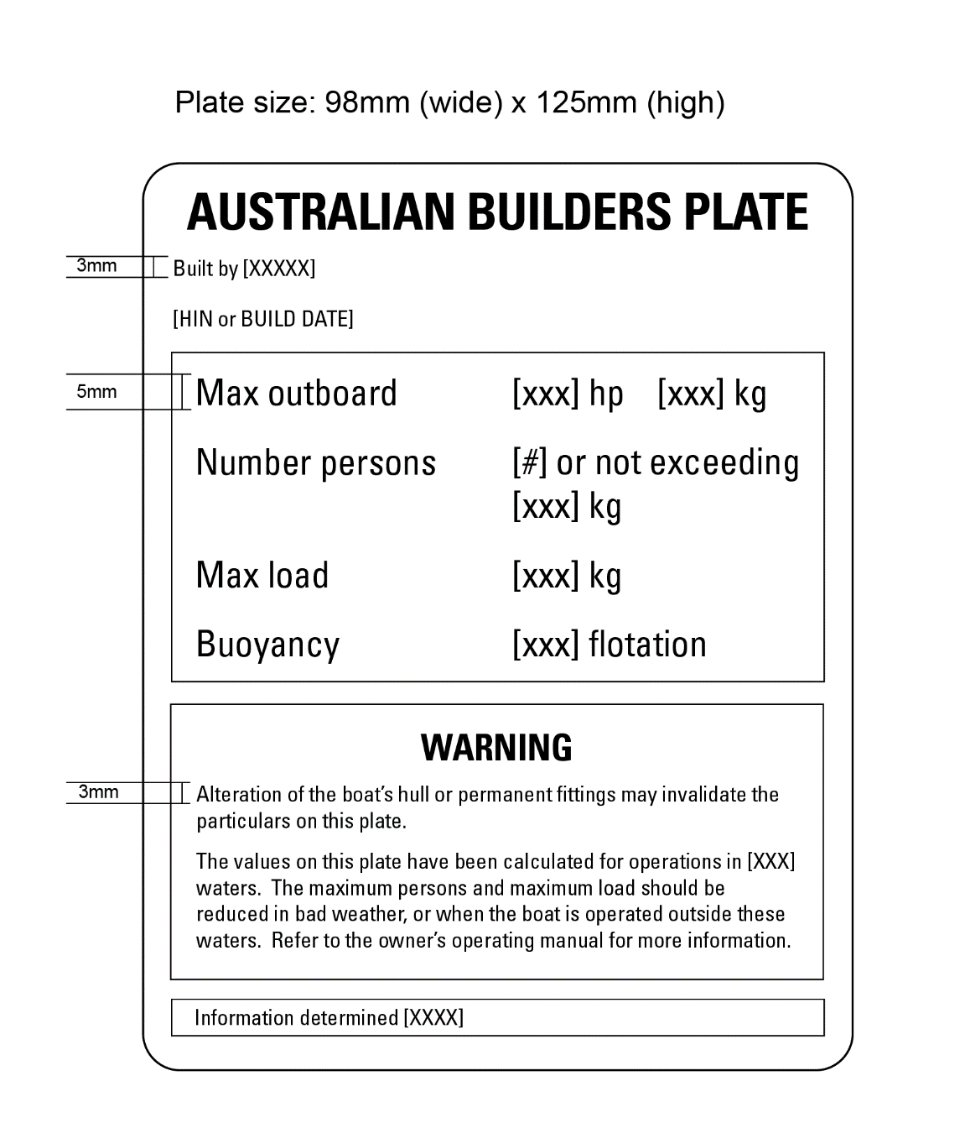 Figure A. 1—Sample ABP template for boats less than 6 metres in length designed to be powered by an outboard engine

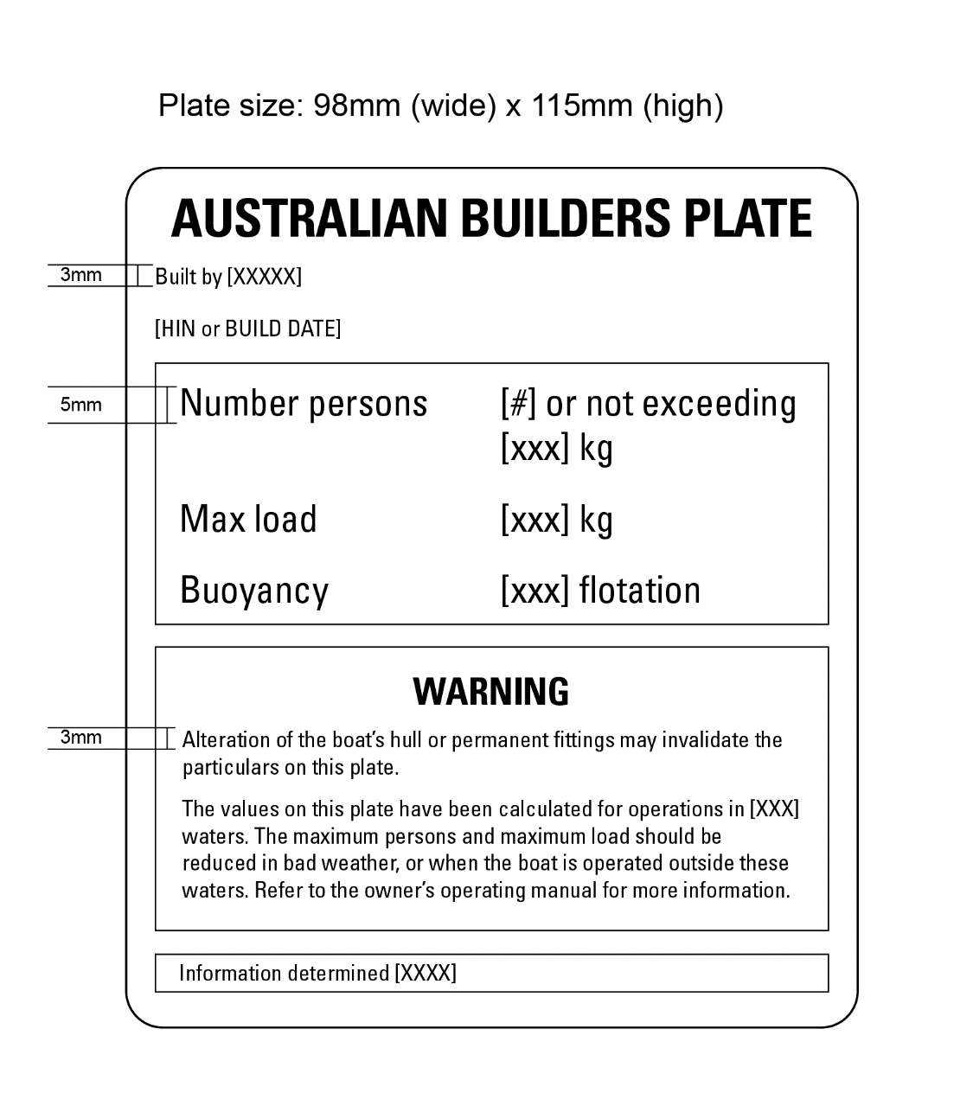
Figure A. 2—Sample ABP template for boats less than 6 metres in length, not designed to be powered by an outboard engine

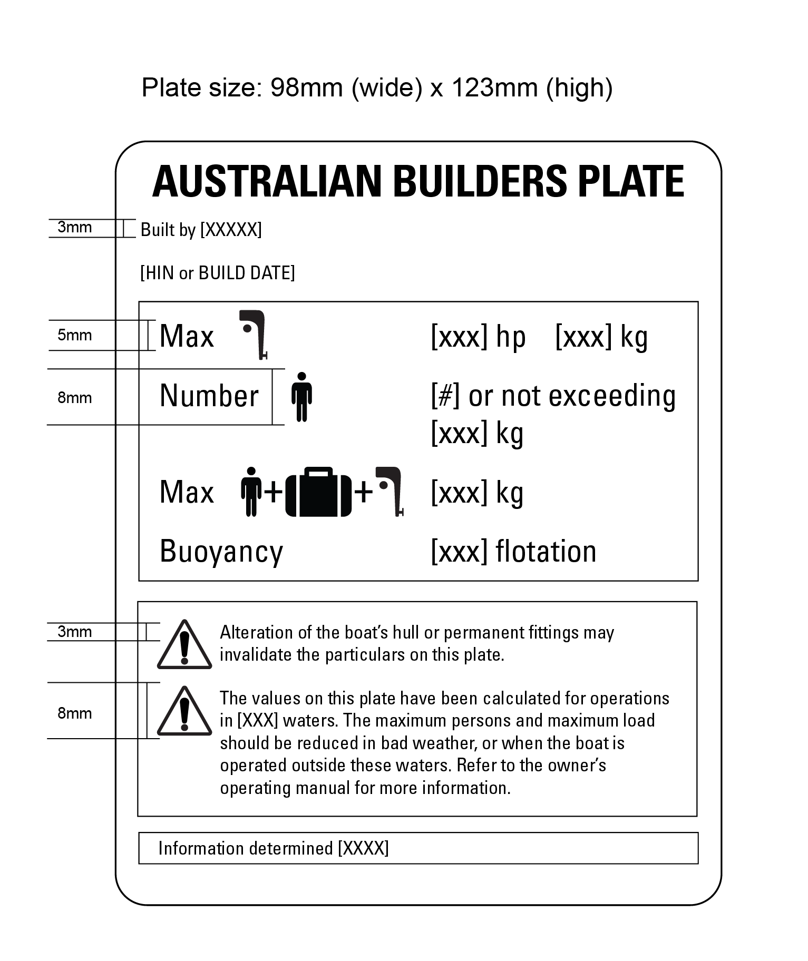
Figure A. 3—Sample ABP template for boats less than 6 metres in length, designed to be powered by an outboard engine,
using text and symbols

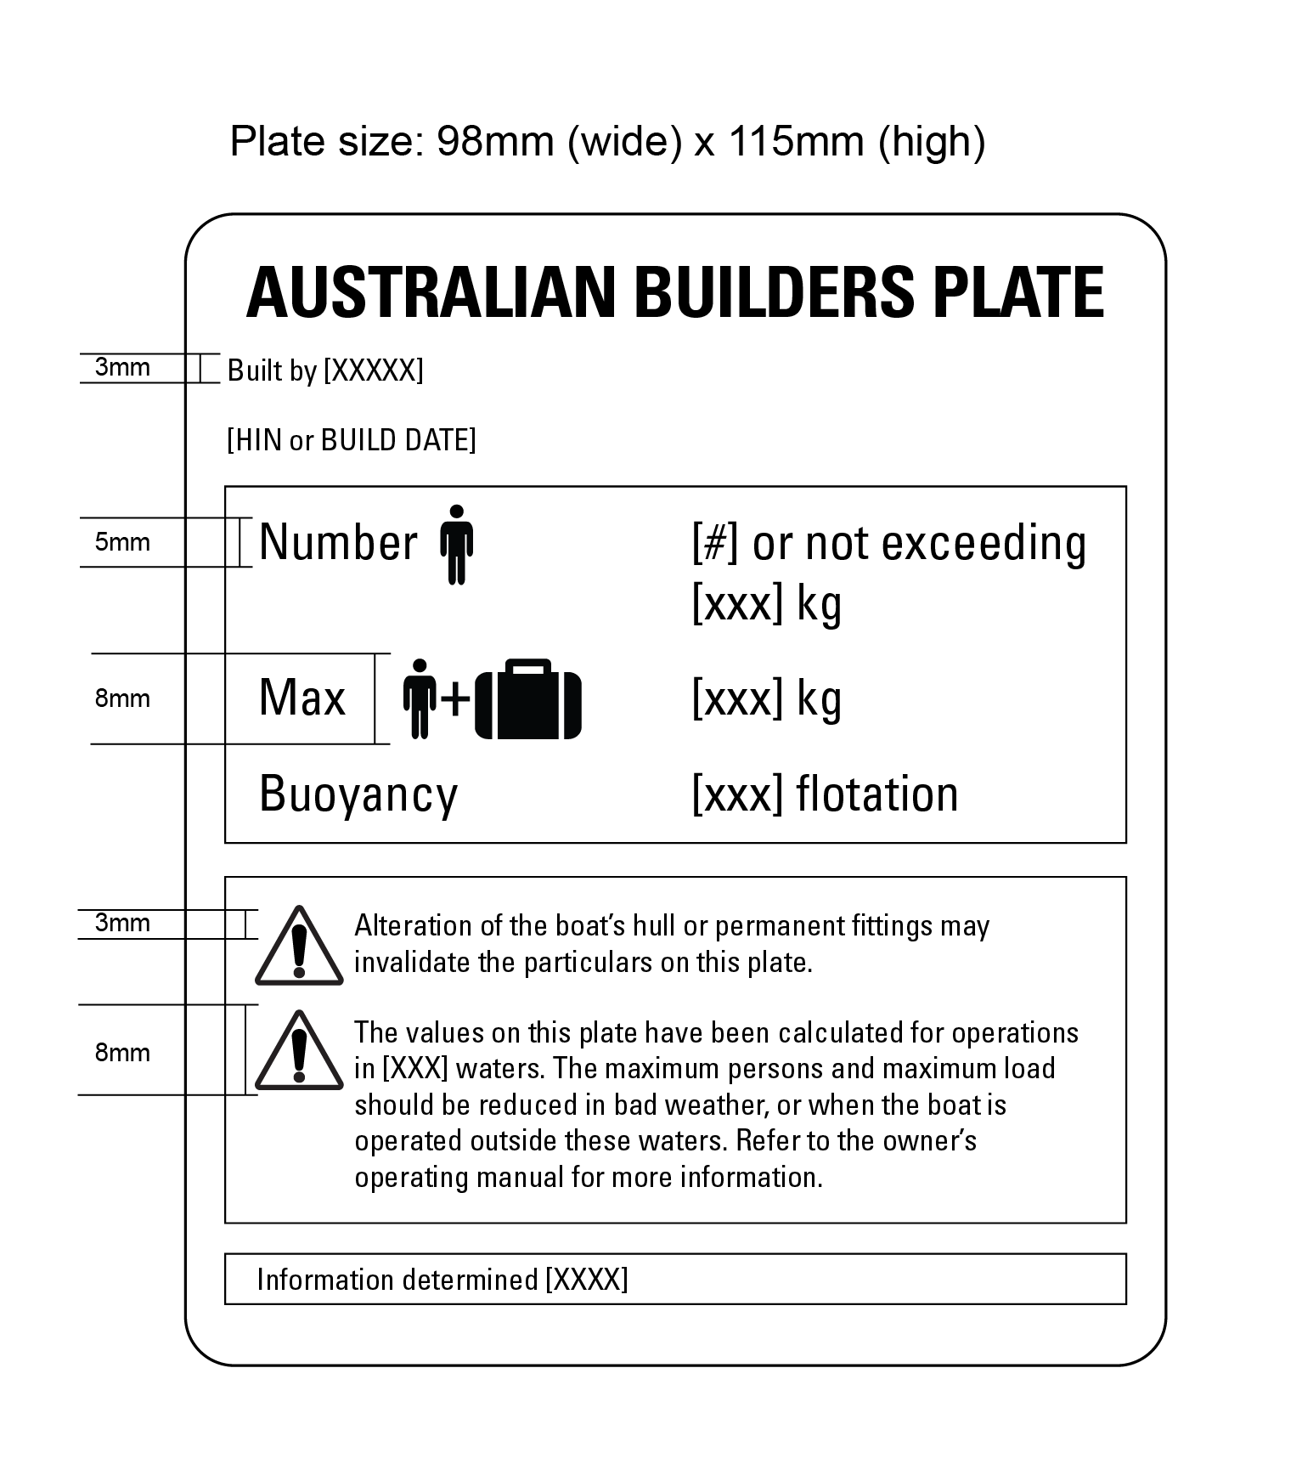
Figure A. 4—Sample ABP template for boats less than 6 metres in length, not designed to be powered by an outboard engine,
using text and symbols

  - ABP templates for boats 6 metres or more in length
Figures A.5 to A.10 illustrate templates that may be used on boats 6 metres or more in length.
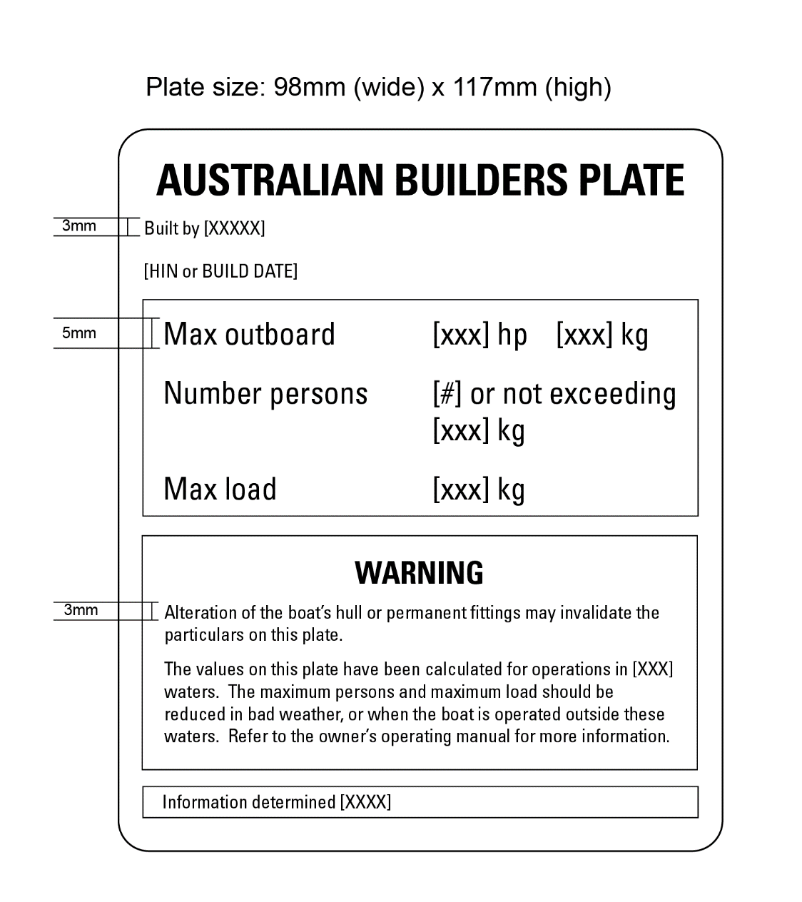
Figure A. 5—Sample ABP template for boats 6 metres or more in length, designed to be powered by an outboard engine

Figure A. 6—Sample ABP template for boats 6 metres or more in length, designed to be powered by an outboard engine, including the optional buoyancy performance statement

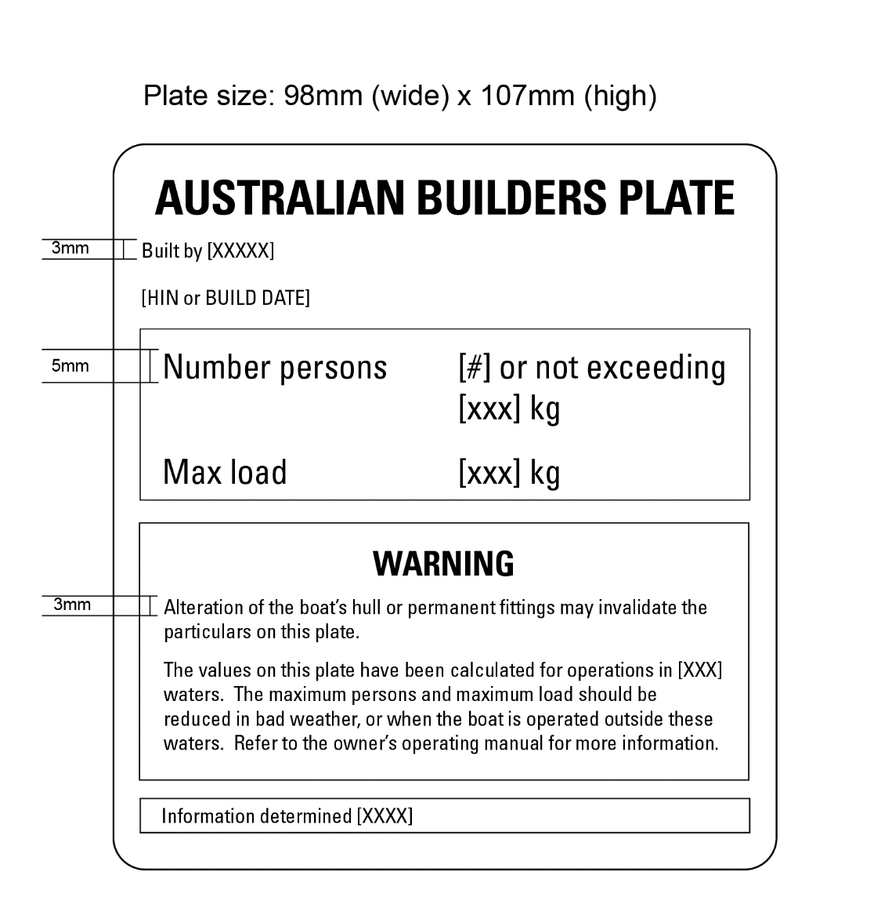
Figure A. 7—Sample ABP template for boats 6 metres or more in length, not designed to be powered by an outboard engine

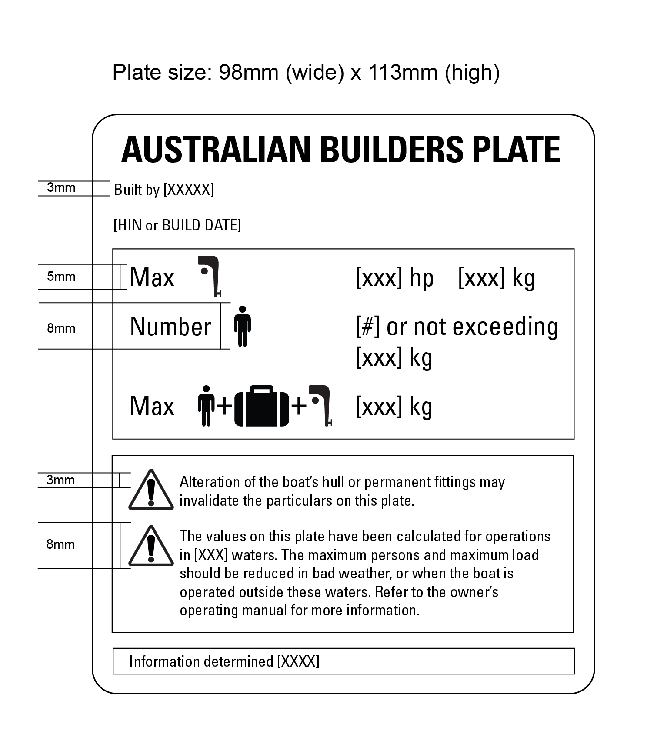
Figure A. 8—Sample ABP template for boats 6 metres or more in length, designed to be powered by an outboard engine,
using text and symbols

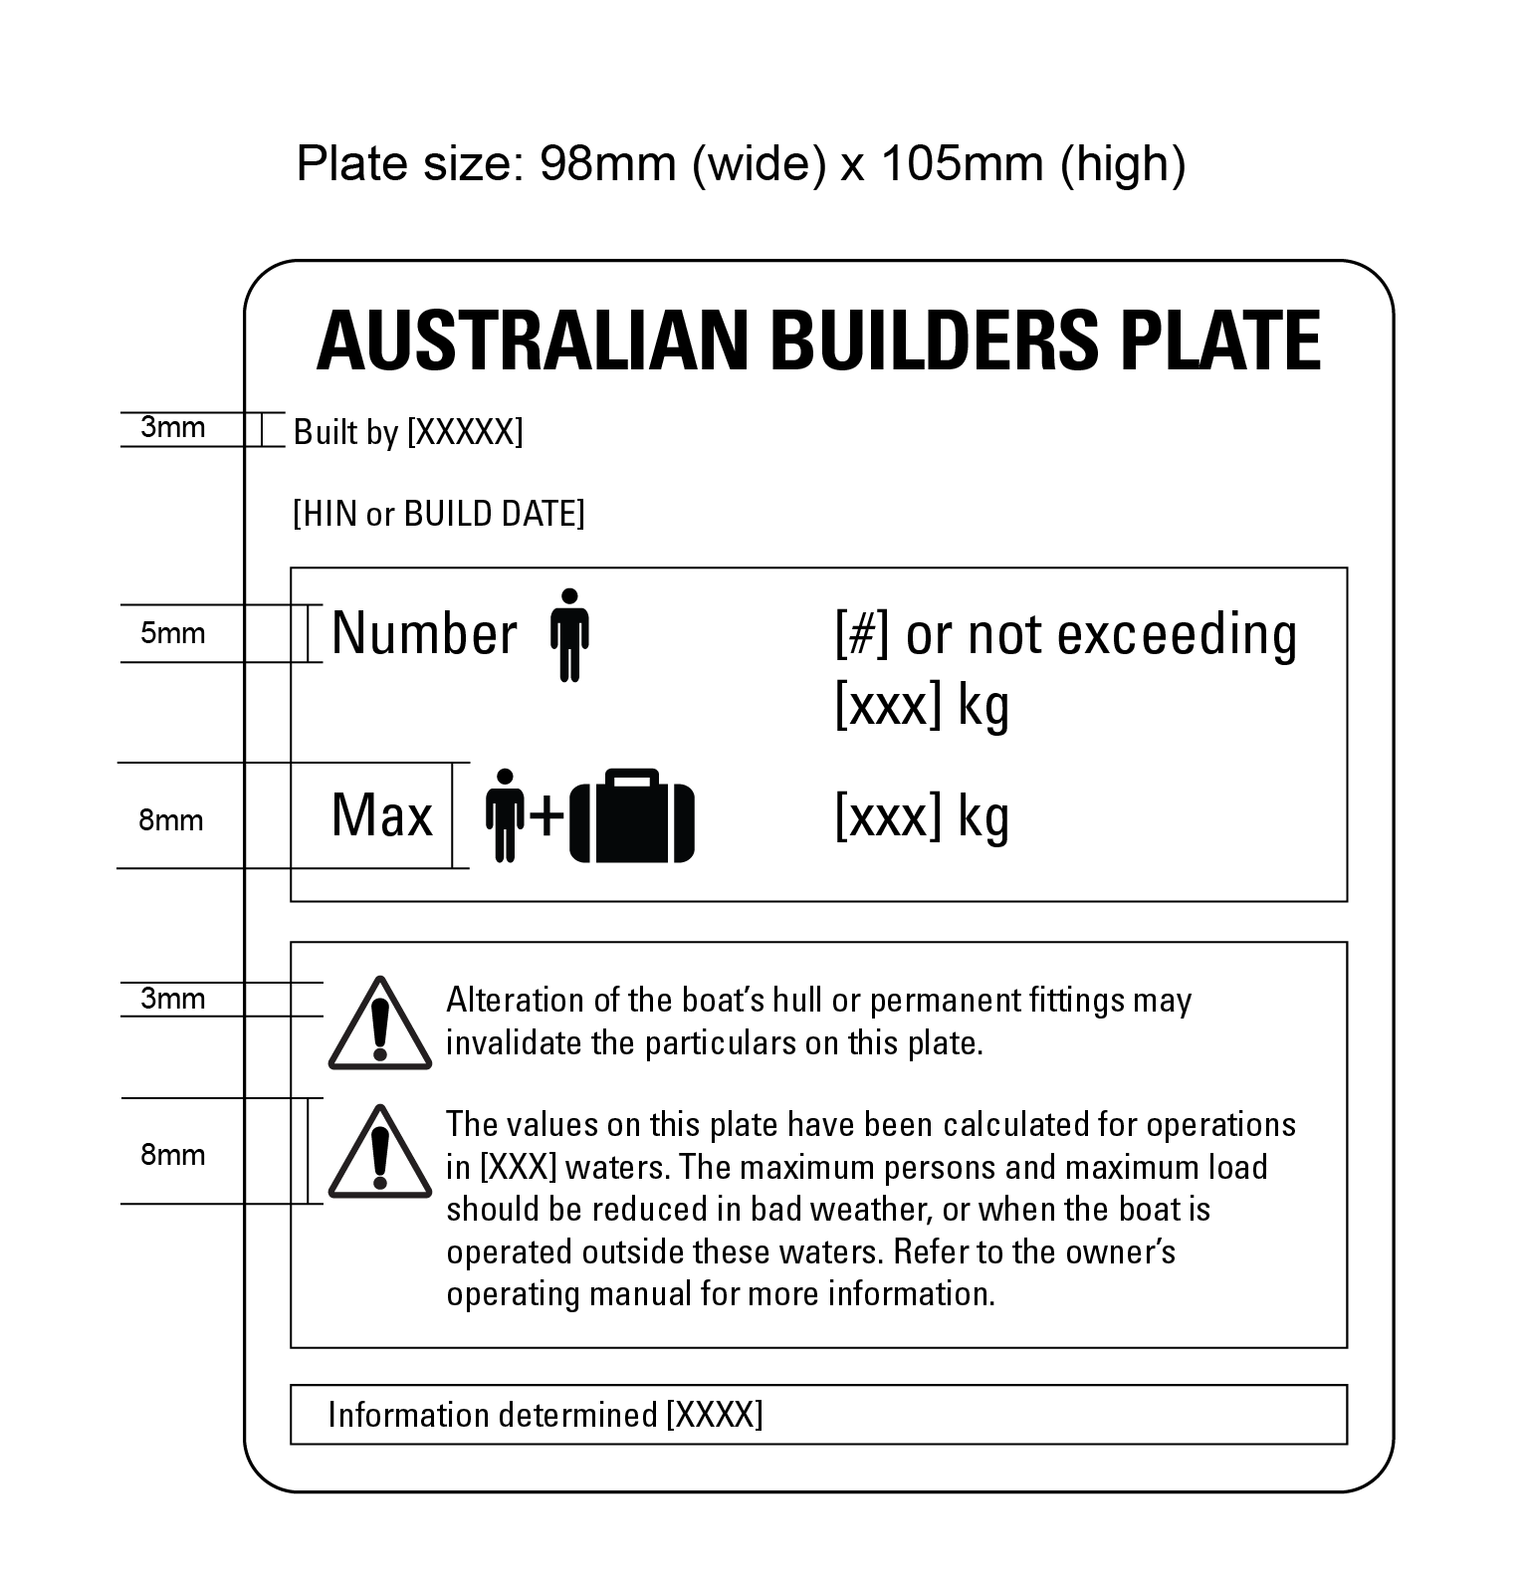
Figure A. 9—Sample ABP template for boats 6 metres or more in length, not designed to be powered by an outboard engine
using text and symbols

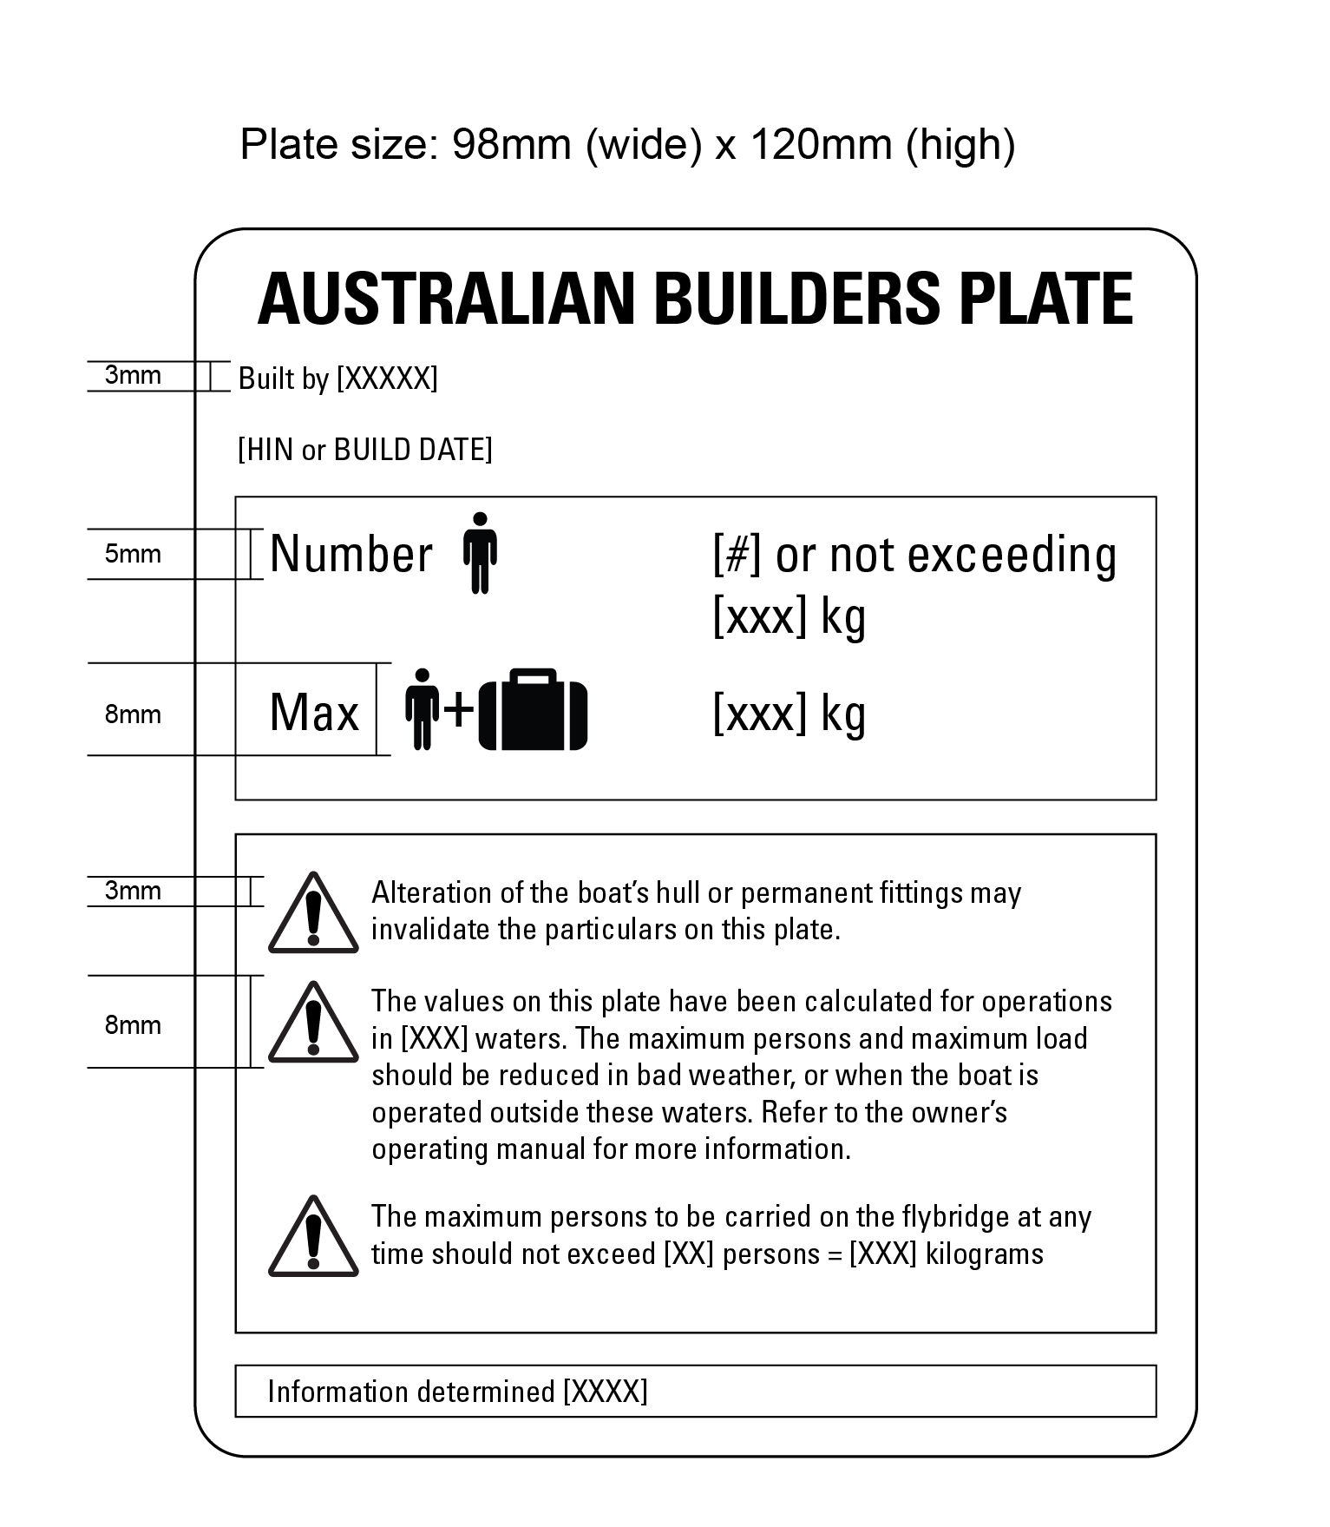
Figure A. 10—Sample ABP template for boats 6 metres or more in length and fitted with a flybridge, not designed to be powered by an outboard engine, using text and symbols

